ANDROID APPLICATION DEVELOPMENT LAB

MCA II A (2)
Khushi Tanwar 25/SCA/MCAN/039
Submitted to: Urvashi Sangwan Ma’am

INDEX

S.  No. | Name of the Program | Date
1 | Create an application that takes the name from a text  box and shows hello message along with the name entered in text box, when the user clicks the OK button
2 | Create a screen that has input boxes for User Name, Password, Address, Gender (radio buttons for male and female), Age (numeric), Date of Birth (Date Picket), State (Spinner) and a Submit button. On clicking the submit button, print all the data below the Submit Button. Use 1. Linear Layout 2. Relative Layout and 3.  Grid Layout or Table Layout.
3 | Develop an application that inserts some notifications into Notification area and whenever a notification is inserted, it should show a toast with details of the  notification.
4 | Develop an application that uses a menu with 3 options for dialing a number, opening a website and to send an SMS. On selecting an option, the appropriate  action should be invoked using intents.
5 | Create an application that uses a text file to store user names and passwords (tab separated fields and one record per line) When the user submits a login name and password through a screen, the details should be verified with the text file data and if they match, show a dialog saying that login is successful. Otherwise, show  the dialog with Login Failed message.
6 | Create an activity to navigate to different activities  through Intents- Implicit and Explicit
7 | Create an activity to create option Menu
8 | Create an activity using Button Controls- CheckBox,  RadioButtons, Radio Groups

Program 1: Create an application that takes the name from a text box and shows hello message along with the name entered in text box, when the user clicks the OK button.

activity_main.xml:
<?xml version="1.0" encoding="utf-8"?>
<LinearLayout xmlns:android="http://schemas.android.com/apk/res/android" android:layout_width="match_parent" android:layout_height="match_parent"
android:orientation="vertical" android:padding="16dp">

<EditText
android:id="@+id/et1" android:layout_width="match_parent" android:layout_height="wrap_content" android:hint="Enter text here" android:inputType="text" />

<Button
android:id="@+id/btn1" android:layout_width="match_parent" android:layout_height="wrap_content" android:text="Click Me" android:layout_marginTop="16dp" />

<TextView
android:id="@+id/tv1" android:layout_width="wrap_content" android:layout_height="wrap_content" android:text="Hello Android!" android:textSize="16sp" android:layout_marginTop="16dp" />

</LinearLayout>

MainActivity.java:
package com.example.enter_username;

import android.os.Bundle; import android.view.View; import android.widget.Button; import android.widget.EditText; import android.widget.TextView; import android.widget.Toast;

import androidx.appcompat.app.AppCompatActivity; public class MainActivity extends AppCompatActivity {
Button btn; EditText et; TextView tv;

@Override
protected void onCreate(Bundle savedInstanceState) { super.onCreate(savedInstanceState); setContentView(R.layout.activity_main);

btn = findViewById(R.id.btn1); et = findViewById(R.id.et1); tv = findViewById(R.id.tv1);

btn.setOnClickListener(new View.OnClickListener() { @Override
public void onClick(View v) {

String text = et.getText().toString(); String message = "Hello " + text; tv.setText(message);
Toast.makeText(MainActivity.this, message, Toast.LENGTH_SHORT).show();
}
});
}
}

Output:

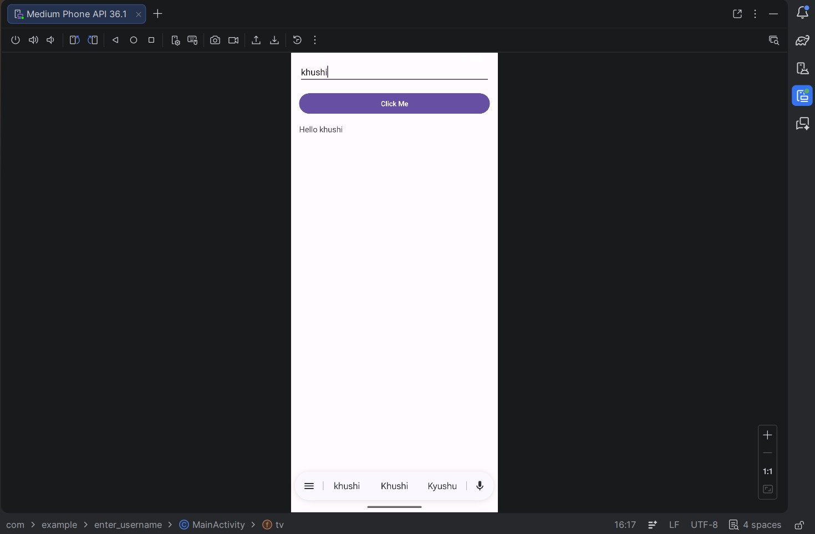

Program 2: Create a screen that has input boxes for User Name, Password, Address, Gender (radio buttons for male and female), Age (numeric), Date of Birth (Date Picket), State (Spinner) and a Submit button. On clicking the submit button, print all the data below the Submit Button. Use 1. Linear Layout 2. Relative Layout and 3. Grid Layout or Table Layout.

activity_main.xml:
<?xml version="1.0" encoding="utf-8"?<ScrollView xmlns:android="http://schemas.android.com/apk/res/android"
android:layout_width="match_parent" android:layout_height="match_parent">

<LinearLayout
android:layout_width="match_parent" android:layout_height="wrap_content" android:orientation="vertical" android:padding="16dp">

<!-- TABLE LAYOUT -->
<TableLayout
android:layout_width="match_parent" android:layout_height="wrap_content">

<!-- Username -->
<TableRow>
<TextView android:text="Username:"/>
<EditText
android:id="@+id/etName" android:layout_width="match_parent" android:inputType="text"/>
</TableRow>

<!-- Password -->
<TableRow>
<TextView android:text="Password:"/>
<EditText
android:id="@+id/etPassword" android:layout_width="match_parent" android:inputType="textPassword"/>
</TableRow>

<!-- Address -->
<TableRow>
<TextView android:text="Address:"/>
<EditText
android:id="@+id/etAddress" android:layout_width="match_parent" android:inputType="textMultiLine"/>
</TableRow>

<!-- Gender -->
<TableRow>
<TextView android:text="Gender:"/>
<RadioGroup
android:id="@+id/radioGroup">

<RadioButton
android:id="@+id/rbMale" android:text="Male"/>

<RadioButton
android:id="@+id/rbFemale" android:text="Female"/>
</RadioGroup>
</TableRow>

<!-- Age -->
<TableRow>
<TextView android:text="Age:"/>
<EditText
android:id="@+id/etAge" android:layout_width="match_parent" android:inputType="number"/>
</TableRow>

<!-- DOB -->
<TableRow>
de<TextView android:text="DOB:"/>
<DatePicker
android:id="@+id/datePicker" android:layout_width="wrap_content"/>
</TableRow>

<!-- State -->
<TableRow>
<TextView android:text="State:"/>
<Spinner
android:id="@+id/spinnerState"/>

</TableRow>

</TableLayout>

<!-- SUBMIT BUTTON -->
<Button
android:id="@+id/btnSubmit" android:layout_width="match_parent" android:layout_height="wrap_content" android:text="Submit" android:layout_marginTop="20dp"/>

<!-- OUTPUT -->
<TextView
android:id="@+id/tvResult" android:layout_width="match_parent" android:layout_height="wrap_content" android:layout_marginTop="20dp" android:textSize="16sp"/>

</LinearLayout>

</ScrollView>

MainActivity.java:
package com.example.formapp;

import android.os.Bundle; import android.view.View; import android.widget.*;
import androidx.appcompat.app.AppCompatActivity; public class MainActivity extend AppCompatActivity {
EditText etName, etPassword, etAddress, etAge;
RadioGroup radioGroup; Spinner spinner; DatePicker datePicker; Button btnSubmit; TextView tvResult;
String[] states = {"Haryana", "Delhi", "Punjab", "UP", "Rajasthan"}; @Override

protected void onCreate(Bundle savedInstanceState) { super.onCreate(savedInstanceState); setContentView(R.layout.activity_main);

etName = findViewById(R.id.etName); etPassword = findViewById(R.id.etPassword); etAddress = findViewById(R.id.etAddress); etAge = findViewById(R.id.etAge); radioGroup = findViewById(R.id.radioGroup); spinner = findViewById(R.id.spinnerState); datePicker = findViewById(R.id.datePicker); btnSubmit = findViewById(R.id.btnSubmit); tvResult = findViewById(R.id.tvResult);

// Spinner setup
ArrayAdapter<String> adapter = new ArrayAdapter<>( this, android.R.layout.simple_spinner_item, states
);
adapter.setDropDownViewResource(android.R.layout.simple_spinner_dropdown_item); spinner.setAdapter(adapter);

btnSubmit.setOnClickListener(new View.OnClickListener() { @Override
public void onClick(View v) {

String name = etName.getText().toString(); String pass = etPassword.getText().toString(); String address = etAddress.getText().toString(); String age = etAge.getText().toString();

int selectedId = radioGroup.getCheckedRadioButtonId(); RadioButton rb = findViewById(selectedId);
String gender = (rb != null) ? rb.getText().toString() : "Not Selected";

int day = datePicker.getDayOfMonth(); int month = datePicker.getMonth() + 1; int year = datePicker.getYear();

String dob = day + "/" + month + "/" + year;

String state = spinner.getSelectedItem().toString();

String result =
"Name: " + name + "\n" +
"Password: " + pass + "\n" +

"Address: " + address + "\n" + "Gender: " + gender + "\n" + "Age: " + age + "\n" +
"DOB: " + dob + "\n" + "State: " + state;

tvResult.setText(result);
}
});
}
}
Output:
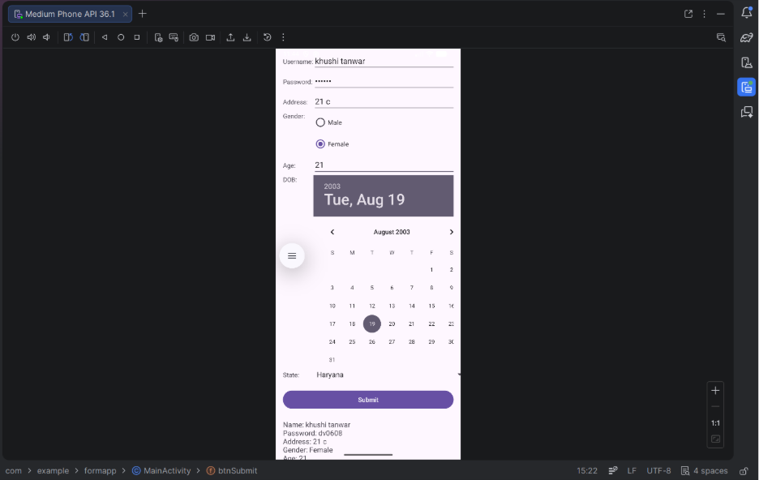

Program 3: Develop an application that inserts some notifications into Notification area and whenever a notification is inserted, it should show a toast with details of the notification.

activity_main.xml:
<?xml version="1.0" encoding="utf-8"?>
<LinearLayout xmlns:android="http://schemas.android.com/apk/res/android" android:layout_width="match_parent" android:layout_height="match_parent"
android:gravity="center" android:orientation="vertical" android:padding="20dp">

<TextView
android:layout_width="wrap_content" android:layout_height="wrap_content" android:text="Notification App" android:textSize="22sp" android:textStyle="bold" android:layout_marginBottom="30dp"/>

<Button
android:id="@+id/btnNotify" android:layout_width="wrap_content" android:layout_height="wrap_content" android:text="Show Notification"/>

</LinearLayout>

MainActivity.java:
package com.example.notificationapp;

import android.app.NotificationChannel; import android.app.NotificationManager; import android.os.Build;
import android.os.Bundle; import android.widget.Button; import android.widget.Toast;

import androidx.appcompat.app.AppCompatActivity; import androidx.core.app.NotificationCompat;

public class MainActivity extends AppCompatActivity {

Button btnNotify;
String CHANNEL_ID = "my_channel";

@Override
protected void onCreate(Bundle savedInstanceState) { super.onCreate(savedInstanceState); setContentView(R.layout.activity_main);

btnNotify = findViewById(R.id.btnNotify);

btnNotify.setOnClickListener(v -> {

String title = "Hello User";
String message = "This is your notification";

// Toast showing notification details Toast.makeText(this,
"Notification: " + title + " - " + message, Toast.LENGTH_LONG).show();

NotificationManager manager =
(NotificationManager) getSystemService(NOTIFICATION_SERVICE);

// For Android 8+
if (Build.VERSION.SDK_INT >= Build.VERSION_CODES.O) {
NotificationChannel channel = new NotificationChannel(
CHANNEL_ID,
"My Channel", NotificationManager.IMPORTANCE_DEFAULT);

manager.createNotificationChannel(channel);
}

NotificationCompat.Builder builder =
new NotificationCompat.Builder(this, CHANNEL_ID)
.setContentTitle(title)
.setContentText(message)
.setSmallIcon(android.R.drawable.ic_dialog_info)
.setAutoCancel(true);

manager.notify(1, builder.build());
});
}
}

Output:
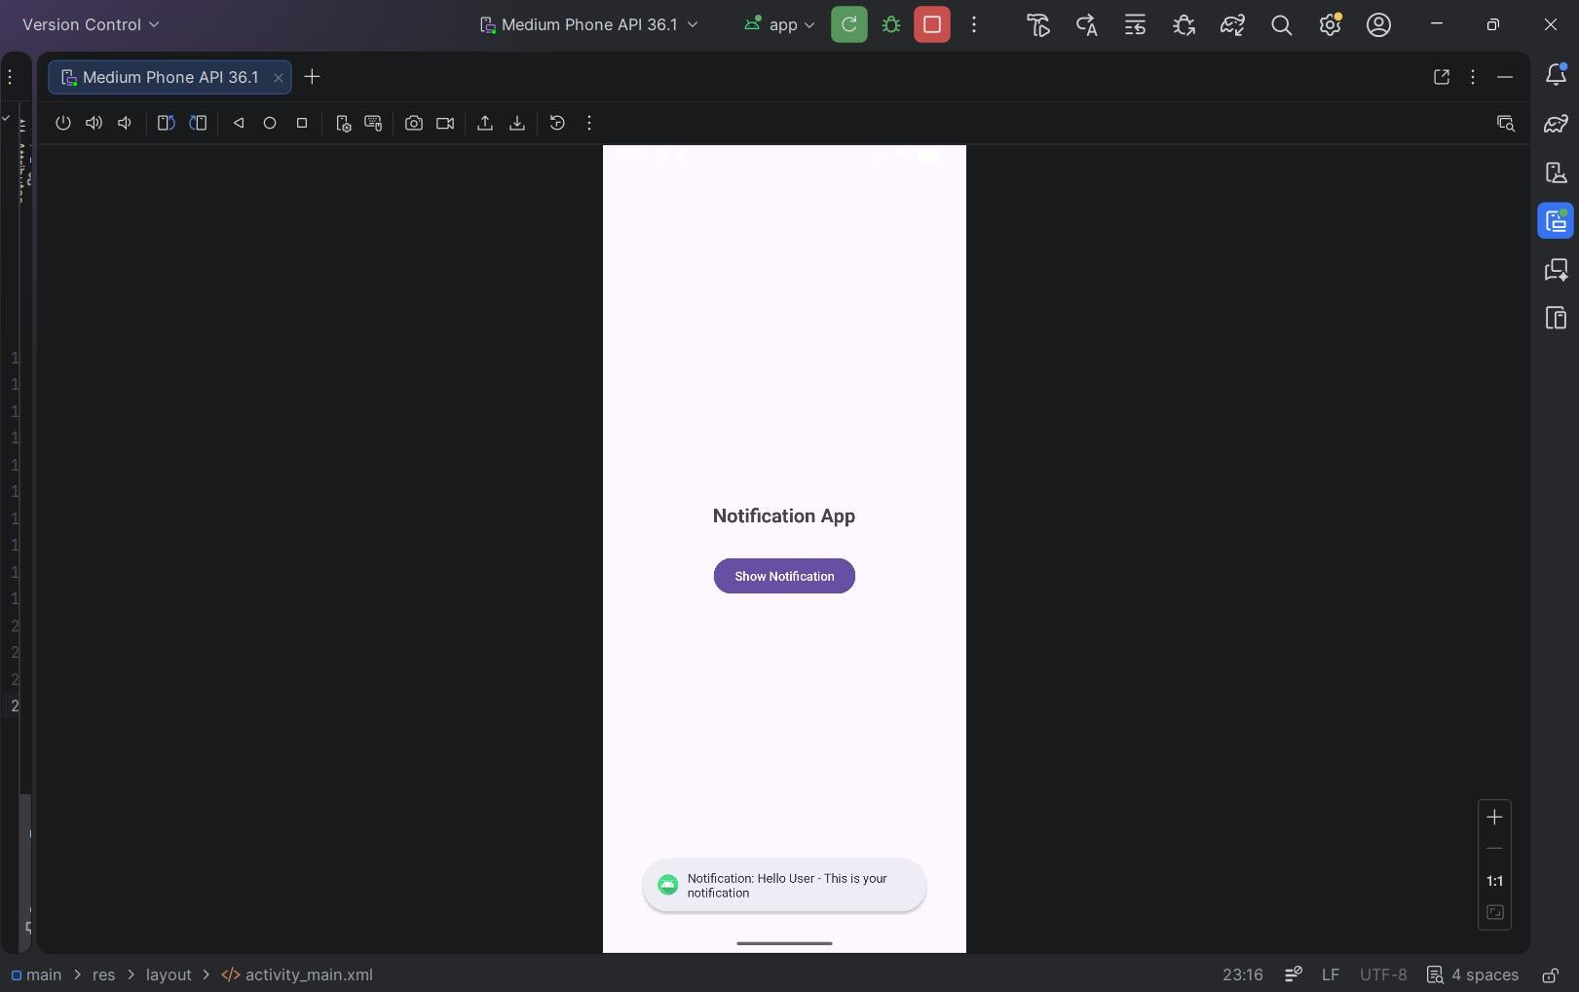

Program 4: Develop an application that uses a menu with 3 options for dialing a number, opening a website and to send an SMS. On selecting an option, the appropriate action should be invoked using intents.

activity_main.xml:
<?xml version="1.0" encoding="utf-8"?>
<LinearLayout xmlns:android="http://schemas.android.com/apk/res/android" android:layout_width="match_parent" android:layout_height="match_parent"
android:gravity="center" android:orientation="vertical">

<TextView
android:layout_width="wrap_content" android:layout_height="wrap_content" android:text="Menu Intent App" android:textSize="22sp" android:textStyle="bold"/>

</LinearLayout>

menu_main.xml:
<?xml version="1.0" encoding="utf-8"?>
<menu xmlns:android="http://schemas.android.com/apk/res/android">

<item
android:id="@+id/menu_call" android:title="Dial Number"/>

<item
android:id="@+id/menu_web" android:title="Open Website"/>

<item
android:id="@+id/menu_sms" android:title="Send SMS"/>

</menu>

MainActivity.java:
package com.example.intentmenu;

import android.content.Intent; import android.net.Uri; import android.os.Bundle;

import android.view.Menu; import android.view.MenuItem;

import androidx.appcompat.app.AppCompatActivity;

public class MainActivity extends AppCompatActivity {

@Override
protected void onCreate(Bundle savedInstanceState) { super.onCreate(savedInstanceState); setContentView(R.layout.activity_main);
}

// Create menu @Override
public boolean onCreateOptionsMenu(Menu menu) { getMenuInflater().inflate(R.menu.menu_main, menu); return true;
}

// Handle menu clicks @Override
public boolean onOptionsItemSelected(MenuItem item) {

int id = item.getItemId();

// Dial Number
if (id == R.id.menu_call) {
Intent intent = new Intent(Intent.ACTION_DIAL); intent.setData(Uri.parse("tel:9876543210")); startActivity(intent);
return true;
}

// Open Website
if (id == R.id.menu_web) {
Intent intent = new Intent(Intent.ACTION_VIEW); intent.setData(Uri.parse("https://www.google.com")); startActivity(intent);
return true;
}

// Send SMS
if (id == R.id.menu_sms) {
Intent intent = new Intent(Intent.ACTION_VIEW); intent.setData(Uri.parse("sms:9876543210")); intent.putExtra("sms_body", "Hello from my app!");

startActivity(intent); return true;
}

return super.onOptionsItemSelected(item);
}
}

Output:

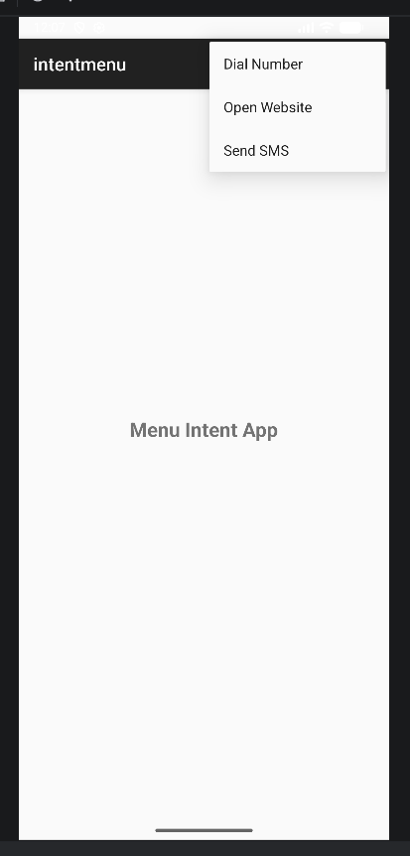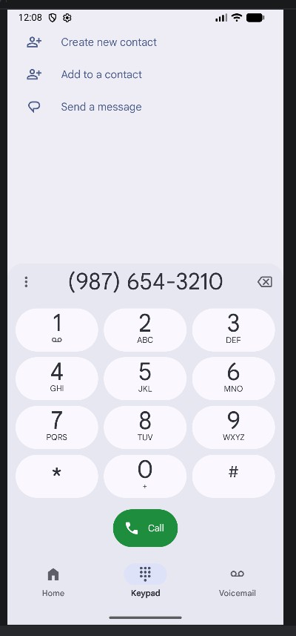

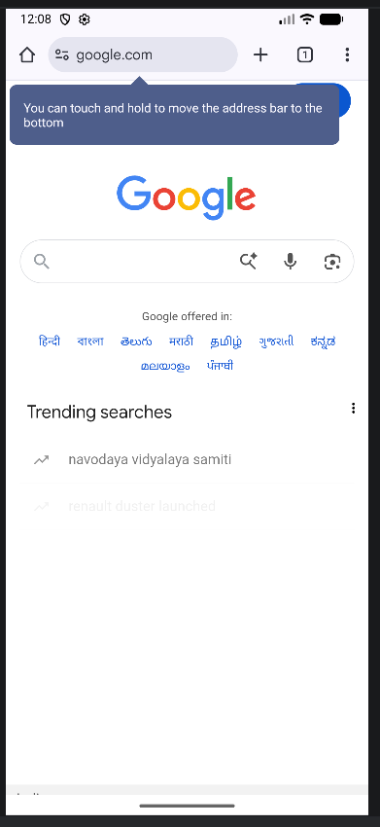

Program 5: Create an application that uses a text file to store user names and passwords (tab separated fields and one record per line) When the user submits a login name and password through a screen, the details should be verified with the text file data and if they match, show a dialog saying that login is successful. Otherwise, show the dialog with Login Failed message.

activity_main.xml:
<?xml version="1.0" encoding="utf-8"?>
<LinearLayout xmlns:android="http://schemas.android.com/apk/res/android" android:layout_width="match_parent" android:layout_height="match_parent"
android:gravity="center" android:orientation="vertical" android:padding="20dp">

<TextView
android:layout_width="wrap_content" android:layout_height="wrap_content" android:text="Login System" android:textSize="22sp" android:textStyle="bold" android:layout_marginBottom="30dp"/>

<EditText
android:id="@+id/etUser" android:layout_width="match_parent" android:layout_height="wrap_content" android:hint="Enter Username"/>

<EditText
android:id="@+id/etPass" android:layout_width="match_parent" android:layout_height="wrap_content" android:hint="Enter Password" android:inputType="textPassword" android:layout_marginTop="10dp"/>

<Button
android:id="@+id/btnLogin" android:layout_width="match_parent" android:layout_height="wrap_content" android:text="Login" android:layout_marginTop="20dp"/>

</LinearLayout>
MainActivity.java:
package com.example.filelogin;

import android.app.AlertDialog; import android.os.Bundle; import android.widget.Button; import android.widget.EditText;
import androidx.appcompat.app.AppCompatActivity; import java.io.BufferedReader;
import java.io.InputStreamReader;

public class MainActivity extends AppCompatActivity {

EditText etUser, etPass; Button btnLogin;

@Override
protected void onCreate(Bundle savedInstanceState) { super.onCreate(savedInstanceState); setContentView(R.layout.activity_main);

etUser = findViewById(R.id.etUser); etPass = findViewById(R.id.etPass); btnLogin = findViewById(R.id.btnLogin);

btnLogin.setOnClickListener(v -> {

String inputUser = etUser.getText().toString(); String inputPass = etPass.getText().toString();

boolean isValid = false;

try {
BufferedReader reader = new BufferedReader(
new InputStreamReader(getAssets().open("users.txt"))
);

String line;

while ((line = reader.readLine()) != null) {

String[] parts = line.split("\t");

if (parts.length == 2) { String fileUser = parts[0]; String filePass = parts[1];

if (inputUser.equals(fileUser) && inputPass.equals(filePass)) { isValid = true;
break;
}
}
}

reader.close();

} catch (Exception e) { e.printStackTrace();
}

if (isValid) {
showDialog("Login Successful");
} else {
showDialog("Login Failed");
}

});
}

private void showDialog(String message) { new AlertDialog.Builder(this)
.setTitle("Result")
.setMessage(message)
.setPositiveButton("OK", null)
.show();
}
}

Users.txt:

dev 123
shweta | 456
raghav | 789
krishna | 1011
khushi | 1022

Output:

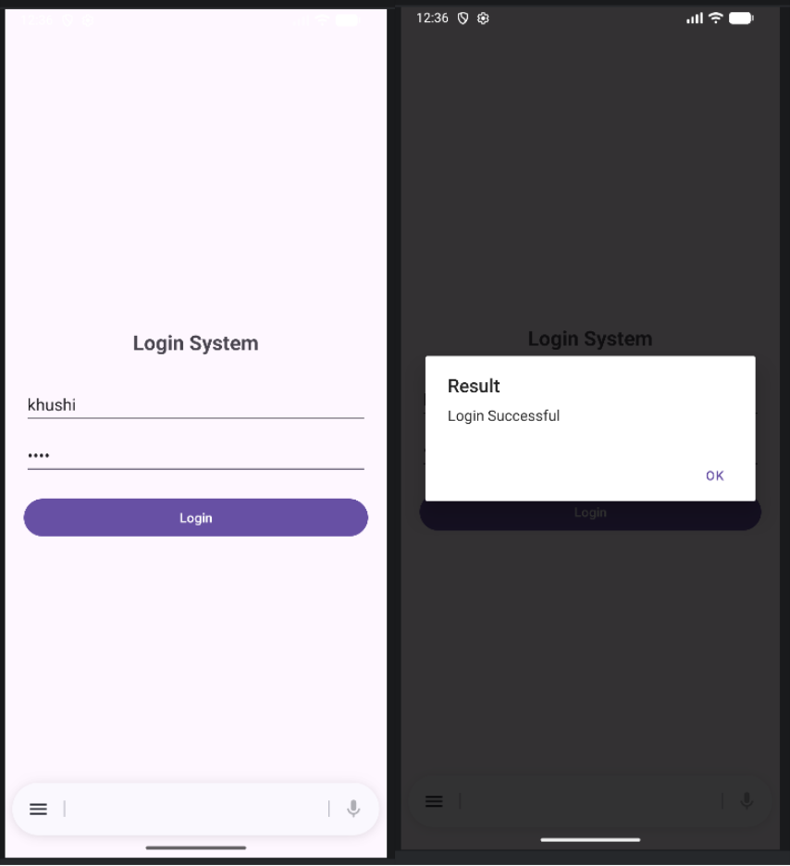

Program 6: Create an activity to navigate to different activities through Intents- Implicit and Explicit

activity_main.xml:
<?xml version="1.0" encoding="utf-8"?>
<LinearLayout xmlns:android="http://schemas.android.com/apk/res/android" android:layout_width="match_parent" android:layout_height="match_parent"
android:gravity="center" android:orientation="vertical" android:padding="20dp">

<TextView
android:layout_width="wrap_content" android:layout_height="wrap_content" android:text="Intent Demo" android:textSize="22sp" android:textStyle="bold" android:layout_marginBottom="30dp"/>

<Button
android:id="@+id/btnExplicit" android:layout_width="match_parent" android:layout_height="wrap_content" android:text="Go to Second Activity" android:layout_marginBottom="15dp"/>

<Button
android:id="@+id/btnWebsite" android:layout_width="match_parent" android:layout_height="wrap_content" android:text="Open Website" android:layout_marginBottom="15dp"/>

<Button
android:id="@+id/btnDial" android:layout_width="match_parent" android:layout_height="wrap_content" android:text="Dial Number"/>

</LinearLayout>

MainActivity.java:

package com.example.intentdemo;

import com.example.intentdemo.SecondActivity; import android.content.Intent;
import android.net.Uri; import android.os.Bundle; import android.widget.Button;

import androidx.appcompat.app.AppCompatActivity;

public class MainActivity extends AppCompatActivity {

Button btnExplicit, btnWebsite, btnDial;

@Override
protected void onCreate(Bundle savedInstanceState) { super.onCreate(savedInstanceState); setContentView(R.layout.activity_main);

btnExplicit = findViewById(R.id.btnExplicit); btnWebsite = findViewById(R.id.btnWebsite); btnDial = findViewById(R.id.btnDial);

// 🔹 EXPLICIT INTENT
btnExplicit.setOnClickListener(v -> {
Intent intent = new Intent(MainActivity.this, SecondActivity.class); startActivity(intent);
});

// 🔹 IMPLICIT INTENT - OPEN WEBSITE
btnWebsite.setOnClickListener(v -> {
Intent intent = new Intent(Intent.ACTION_VIEW); intent.setData(Uri.parse("https://www.google.com")); startActivity(intent);
});

// 🔹 IMPLICIT INTENT - DIAL
btnDial.setOnClickListener(v -> {
Intent intent = new Intent(Intent.ACTION_DIAL); intent.setData(Uri.parse("tel:9876543210")); startActivity(intent);
});
}
}

activity_second.xml:
<?xml version="1.0" encoding="utf-8"?>
<LinearLayout xmlns:android="http://schemas.android.com/apk/res/android" android:layout_width="match_parent" android:layout_height="match_parent"
android:gravity="center" android:orientation="vertical">

<TextView
android:layout_width="wrap_content" android:layout_height="wrap_content" android:text="This is Second Activity" android:textSize="20sp" android:textStyle="bold"/>

</LinearLayout>

SecondActivity.java:
package com.example.intentdemo;

import android.os.Bundle;
import androidx.appcompat.app.AppCompatActivity; public class SecondActivity extends AppCompatActivity {
@Override
protected void onCreate(Bundle savedInstanceState) { super.onCreate(savedInstanceState); setContentView(R.layout.activity_second);
}
}

Output:

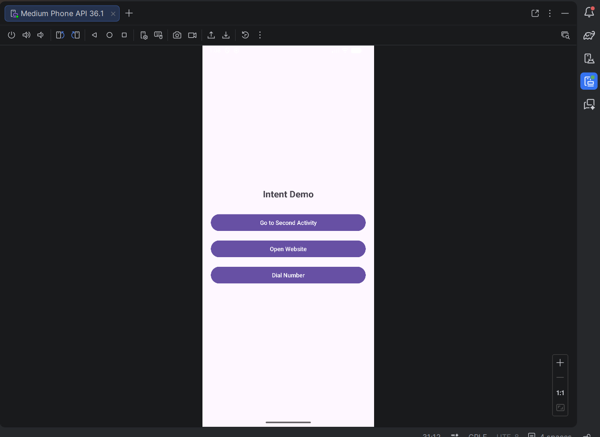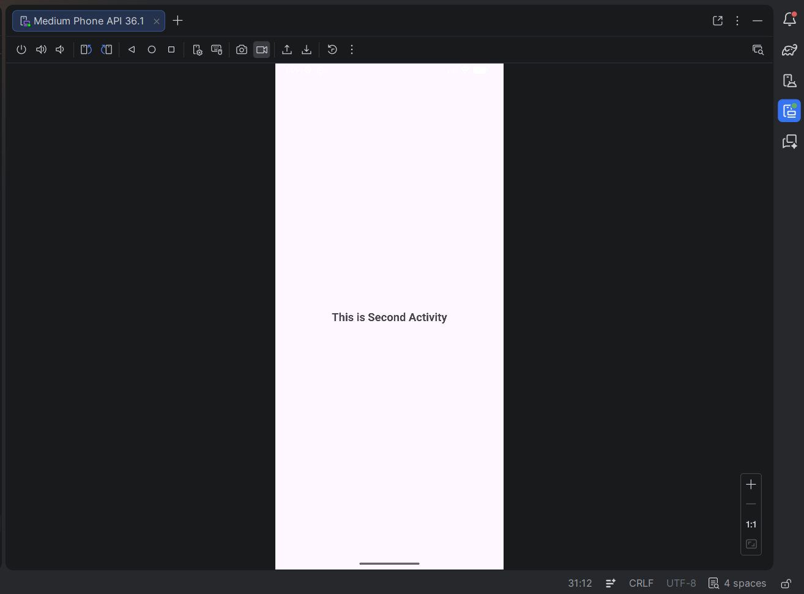

Program 7: Create an activity to create option Menu.

activity_main.xml:
<?xml version="1.0" encoding="utf-8"?>
<RelativeLayout xmlns:android="http://schemas.android.com/apk/res/android" xmlns:tools="http://schemas.android.com/tools" android:layout_width="match_parent" android:layout_height="match_parent"
tools:context=".MainActivity">

<TextView
android:id="@+id/textView" android:layout_width="wrap_content" android:layout_height="wrap_content" android:text="Option Menu" android:textSize="22sp" android:textStyle="bold" android:layout_centerInParent="true" />

</RelativeLayout>

MainActivity.java:
package com.example.optionmenu;

import android.os.Bundle; import android.view.Menu; import android.view.MenuItem; import android.widget.Toast;
import androidx.appcompat.app.AppCompatActivity; public class MainActivity extends AppCompatActivity {
@Override
protected void onCreate(Bundle savedInstanceState) { super.onCreate(savedInstanceState); setContentView(R.layout.activity_main);
}

// Step 1: Create Option Menu @Override
public boolean onCreateOptionsMenu(Menu menu) { menu.add(0, 1, 0, "Settings");
menu.add(0, 2, 0, "Profile");

menu.add(0, 3, 0, "Logout"); return true;
}

// Step 2: Handle Menu Clicks @Override
public boolean onOptionsItemSelected(MenuItem item) {

switch (item.getItemId()) { case 1:
Toast.makeText(this, "Settings Clicked", Toast.LENGTH_SHORT).show(); return true;

case 2:
Toast.makeText(this, "Profile Clicked", Toast.LENGTH_SHORT).show(); return true;

case 3:
Toast.makeText(this, "Logout Clicked", Toast.LENGTH_SHORT).show(); return true;

default:
return super.onOptionsItemSelected(item);
}
}
}

Output:

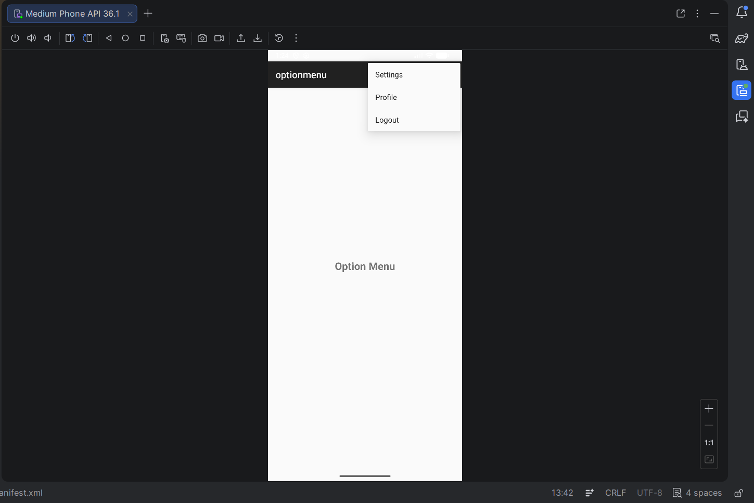

Program 8: Create an activity using Button Controls- CheckBox, RadioButtons, Radio Groups

activity_main.xml:
<?xml version="1.0" encoding="utf-8"?>
<LinearLayout xmlns:android="http://schemas.android.com/apk/res/android" android:layout_width="match_parent" android:layout_height="match_parent"
android:orientation="vertical" android:padding="20dp">

<!-- CheckBox -->
<CheckBox

android:id="@+id/checkBox" android:layout_width="wrap_content" android:layout_height="wrap_content" android:text="Accept Terms and Conditions" />

<!-- RadioGroup -->
<RadioGroup
android:id="@+id/radioGroup" android:layout_width="wrap_content" android:layout_height="wrap_content" android:layout_marginTop="20dp">

<RadioButton
android:id="@+id/radioMale" android:layout_width="wrap_content" android:layout_height="wrap_content" android:text="Male" />

<RadioButton
android:id="@+id/radioFemale" android:layout_width="wrap_content" android:layout_height="wrap_content" android:text="Female" />

</RadioGroup>

<!-- Button -->
<Button
android:id="@+id/btnSubmit" android:layout_width="wrap_content" android:layout_height="wrap_content" android:text="Submit" android:layout_marginTop="20dp"/>

</LinearLayout>

MainActivity.java:
package com.example.buttoncontrols;

import android.os.Bundle; import android.view.View; import android.widget.Button; import android.widget.CheckBox;
import android.widget.RadioButton; import android.widget.RadioGroup; import android.widget.Toast;

import androidx.appcompat.app.AppCompatActivity;

public class MainActivity extends AppCompatActivity {

CheckBox checkBox; RadioGroup radioGroup; Button btnSubmit;

@Override
protected void onCreate(Bundle savedInstanceState) { super.onCreate(savedInstanceState); setContentView(R.layout.activity_main);

checkBox = findViewById(R.id.checkBox); radioGroup = findViewById(R.id.radioGroup); btnSubmit = findViewById(R.id.btnSubmit);

btnSubmit.setOnClickListener(new View.OnClickListener() { @Override
public void onClick(View v) {

// CheckBox state
boolean isChecked = checkBox.isChecked();

// RadioButton selected
int selectedId = radioGroup.getCheckedRadioButtonId();

if (selectedId == -1) { Toast.makeText(MainActivity.this, "Select Gender",
Toast.LENGTH_SHORT).show();
return;
}

RadioButton selectedRadio = findViewById(selectedId); String gender = selectedRadio.getText().toString();

// Show result
String message = "Accepted: " + isChecked + "\nGender: " + gender;

Toast.makeText(MainActivity.this, message, Toast.LENGTH_LONG).show();
}
});
}
}

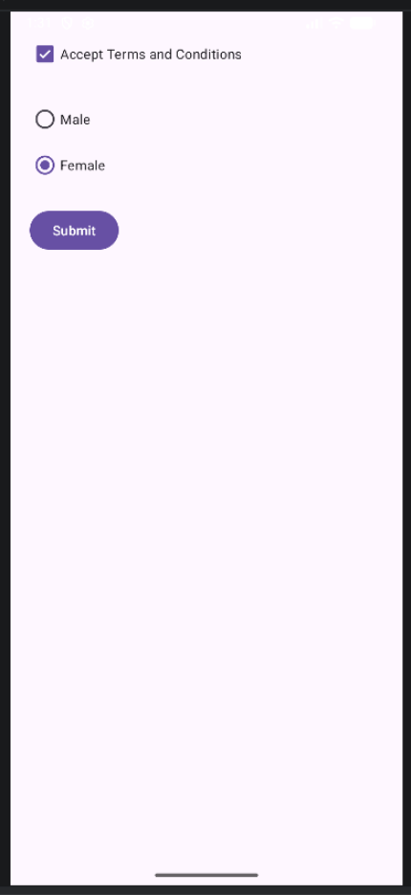
Output:

INDEX

S.No. | Name of the Programs(Intermediate level) | Date
1 | Develop an application that shows names as a list and on selecting a name, it should show the details of the candidate on the next screen with a back button. If the screen is rotated to landscape mode width greater than height, then the screen should show list on left fragment and details on right fragment instead of second screen with back button, use fragment transactions and  rotation event listener.
2 | - Create a user registration application that stores the user details in a database table  - Create a database and a user table where the details of login names and password are stored. Insert some names and password. Initially now the login details entered by the user should be verified with the database and an appropriate dialogue should be shown to the user.
3 | Create an admin application for the user table, which shows all records as a list and the administration. Select any record for edit or modify. The result should be reflected in the table.
4 | Create an alarm that rings every Sunday at 8 AM, modify it to use a time, picker to set alarm time.
5 | Create an activity that uses a menu with three options for dialogue, a number, opening a website and to send an SMS.
6 | Basic music player app.

Program-2
- Create a user registration application that stores the user details in a database table
- Create a database and a user table where the details of login names and password are stored. Insert some names and password. Initially now the login details entered by the user should be verified with the database and an appropriate dialogue should be shown to the user.

activity_main.xml:
<?xml version="1.0" encoding="utf-8"?>
<manifest xmlns:android="http://schemas.android.com/apk/res/android" xmlns:tools="http://schemas.android.com/tools">
<application android:allowBackup="true"
android:dataExtractionRules="@xml/data_extraction_rules" android:fullBackupContent="@xml/backup_rules" android:icon="@mipmap/ic_launcher" android:label="@string/app_name" android:roundIcon="@mipmap/ic_launcher_round" android:supportsRtl="true"
android:theme="@style/Theme._2UserRegistrationAPPLICATIONSTOREUSERDETAILS INDATABASE">
<activity android:name=".MainActivity" android:exported="true">
<intent-filter>
<action android:name="android.intent.action.MAIN" />
<category android:name="android.intent.category.LAUNCHER" />
</intent-filter>
</activity>
</application>
</manifest>

MainActivity.java:
package com.example.a2userregistrationapplicationstoreuserdetailsindatabase;
import android.os.Bundle; import android.view.View; import android.widget.Button; import android.widget.EditText; import android.widget.Toast;

import androidx.appcompat.app.AlertDialog;
import androidx.appcompat.app.AppCompatActivity;

public class MainActivity extends AppCompatActivity {
EditText etUsername, etPassword; Button btnRegister, btnLogin; DatabaseHelper db;

@Override
protected void onCreate(Bundle savedInstanceState) { super.onCreate(savedInstanceState); setContentView(R.layout.activity_main);

db = new DatabaseHelper(this);
etUsername = findViewById(R.id.etUsername); etPassword = findViewById(R.id.etPassword); btnRegister = findViewById(R.id.btnRegister); btnLogin = findViewById(R.id.btnLogin);

btnRegister.setOnClickListener(new View.OnClickListener() { @Override
public void onClick(View v) {
String username = etUsername.getText().toString(); String password = etPassword.getText().toString();
if (username.isEmpty() || password.isEmpty()) { Toast.makeText(MainActivity.this, "Please fill all fields",
Toast.LENGTH_SHORT).show();
} else {
boolean success = db.insertUser(username, password); if (success) {
Toast.makeText(MainActivity.this, "Registration successful", Toast.LENGTH_SHORT).show();
} else {
Toast.makeText(MainActivity.this, "Registration failed", Toast.LENGTH_SHORT).show();
}
}
}
});
btnLogin.setOnClickListener(new View.OnClickListener() { @Override
public void onClick(View v) {
String username = etUsername.getText().toString(); String password = etPassword.getText().toString();

if (db.checkUser(username, password)) {
showDialog("Login Successful", "Welcome, " + username + "!");
} else {
showDialog("Login Failed", "Invalid username or password.");
}
}
});
}
private void showDialog(String title, String message) { AlertDialog.Builder builder = new AlertDialog.Builder(this); builder.setTitle(title)
.setMessage(message)
.setPositiveButton("OK", null)
.show();
}
}
Output-
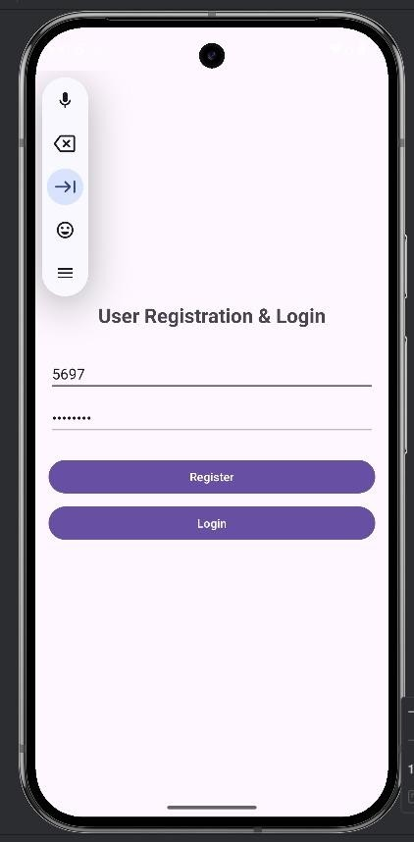

Program-3
Create an admin application for the user table, which shows all records as a list and the administration. Select any record for edit or modify. The result should be reflected in the table.

activity_main.xml:
<?xml version="1.0" encoding="utf-8"?>
<manifest xmlns:android="http://schemas.android.com/apk/res/android" xmlns:tools="http://schemas.android.com/tools">
<application android:allowBackup="true"
android:dataExtractionRules="@xml/data_extraction_rules" android:fullBackupContent="@xml/backup_rules" android:icon="@mipmap/ic_launcher" android:label="@string/app_name" android:roundIcon="@mipmap/ic_launcher_round" android:supportsRtl="true" android:theme="@style/Theme._3UserAdminManager">
<activity android:name=".MainActivity" android:exported="true">
<intent-filter>
<action android:name="android.intent.action.MAIN" />
<category android:name="android.intent.category.LAUNCHER" />
</intent-filter>
</activity>
<activity android:name=".EditUserActivity" />
</application>
</manifest>

MainActivity.java:
package com.example.a3useradminmanager;
import android.content.Intent; import android.os.Bundle; import android.view.View;
import android.widget.AdapterView; import android.widget.ListView;

import androidx.appcompat.app.AppCompatActivity; import java.util.List;

public class MainActivity extends AppCompatActivity { private ListView listViewUsers;
private DatabaseHelper databaseHelper; private UserAdapter userAdapter; private List<User> userList;

@Override
protected void onCreate(Bundle savedInstanceState) { super.onCreate(savedInstanceState); setContentView(R.layout.activity_main);

listViewUsers = findViewById(R.id.listViewUsers); databaseHelper = new DatabaseHelper(this);
refreshUserList();

listViewUsers.setOnItemClickListener(new AdapterView.OnItemClickListener() { @Override
public void onItemClick(AdapterView<?> parent, View view, int position, long id) { User selectedUser = userList.get(position);
Intent intent = new Intent(MainActivity.this, EditUserActivity.class); intent.putExtra("user", selectedUser);
startActivity(intent);
}
});
}
@Override
protected void onResume() { super.onResume(); refreshUserList();
}
private void refreshUserList() {
userList = databaseHelper.getAllUsers(); userAdapter = new UserAdapter(this, userList); listViewUsers.setAdapter(userAdapter);
}
}

Output-
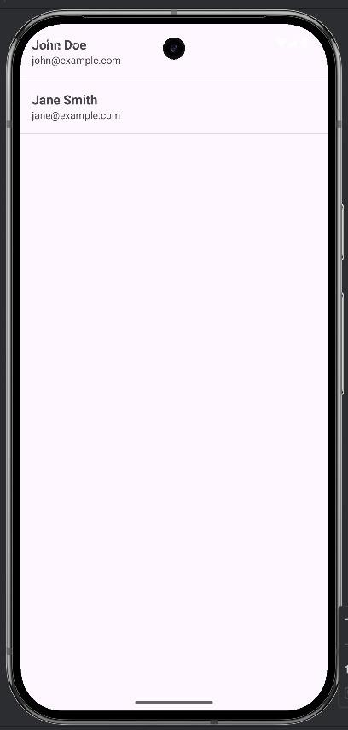

Program-4
Create an alarm that rings every Sunday at 8 AM, modify it to use a time, picker to set alarm time.

activity_main.xml:
<?xml version="1.0" encoding="utf-8"?>
<manifest xmlns:android="http://schemas.android.com/apk/res/android" xmlns:tools="http://schemas.android.com/tools">

<uses-permission android:name="android.permission.SCHEDULE_EXACT_ALARM" />
<uses-permission android:name="android.permission.POST_NOTIFICATIONS" />
<application android:allowBackup="true"
android:dataExtractionRules="@xml/data_extraction_rules" android:fullBackupContent="@xml/backup_rules" android:icon="@mipmap/ic_launcher" android:label="@string/app_name" android:roundIcon="@mipmap/ic_launcher_round" android:supportsRtl="true" android:theme="@style/Theme._4SundayAlarmApp">
<activity android:name=".MainActivity" android:exported="true">
<intent-filter>
<action android:name="android.intent.action.MAIN" />
<category android:name="android.intent.category.LAUNCHER" />
</intent-filter>
</activity>

<receiver android:name=".AlarmReceiver" android:exported="false" />
</application>

</manifest>

MainActivity.java:
package com.example.a4sundayalarmapp;
import android.Manifest;
import android.app.AlarmManager; import android.app.PendingIntent; import android.app.TimePickerDialog; import android.content.Context;

import android.content.Intent;
import android.content.pm.PackageManager; import android.os.Build;
import android.os.Bundle; import android.provider.Settings; import android.widget.Button;
import android.widget.TextView; import android.widget.Toast;
import androidx.activity.EdgeToEdge;
import androidx.activity.result.ActivityResultLauncher;
import androidx.activity.result.contract.ActivityResultContracts; import androidx.appcompat.app.AppCompatActivity;
import androidx.core.content.ContextCompat; import androidx.core.graphics.Insets;
import androidx.core.view.ViewCompat;
import androidx.core.view.WindowInsetsCompat;
import java.util.Calendar; import java.util.Locale;
public class MainActivity extends AppCompatActivity { private TextView tvAlarmTime;
private final ActivityResultLauncher<String> requestPermissionLauncher = registerForActivityResult(new ActivityResultContracts.RequestPermission(),
isGranted -> {
if (isGranted) { showTimePicker();
} else {
Toast.makeText(this, "Notification permission denied. You won't see the alarm notification.", Toast.LENGTH_LONG).show();
// Still show picker because the alarm itself doesn't require notification permission to be scheduled
showTimePicker();
}
});
@Override
protected void onCreate(Bundle savedInstanceState) { super.onCreate(savedInstanceState); EdgeToEdge.enable(this); setContentView(R.layout.activity_main);
ViewCompat.setOnApplyWindowInsetsListener(findViewById(R.id.main), (v, insets) -
> {
Insets systemBars = insets.getInsets(WindowInsetsCompat.Type.systemBars());

v.setPadding(systemBars.left, systemBars.top, systemBars.right, systemBars.bottom); return insets;
});

tvAlarmTime = findViewById(R.id.tvAlarmTime); Button btnSetAlarm = findViewById(R.id.btnSetAlarm);
btnSetAlarm.setOnClickListener(v -> checkPermissionsAndShowPicker());
}

private void checkPermissionsAndShowPicker() {
if (Build.VERSION.SDK_INT >= Build.VERSION_CODES.TIRAMISU) {
if (ContextCompat.checkSelfPermission(this, Manifest.permission.POST_NOTIFICATIONS) != PackageManager.PERMISSION_GRANTED) {

requestPermissionLauncher.launch(Manifest.permission.POST_NOTIFICATIONS);
} else {
showTimePicker();
}
} else {
showTimePicker();
}
}
private void showTimePicker() {
// Default to 8:00 AM as requested int hour = 8;
int minute = 0;
TimePickerDialog timePickerDialog = new TimePickerDialog(this, (view, hourOfDay, minute1) -> {
setSundayAlarm(hourOfDay, minute1); tvAlarmTime.setText(String.format(Locale.getDefault(), "Sunday Alarm set
for %02d:%02d", hourOfDay, minute1));
}, hour, minute, true);
timePickerDialog.show();
}
private void setSundayAlarm(int hour, int minute) { AlarmManager alarmManager = (AlarmManager)
getSystemService(Context.ALARM_SERVICE);

// For Android 12+, we need to check if we can schedule exact alarms if we were using setExact
// For setRepeating, it's generally inexact anyway, so this might not be strictly required

// unless we want it to be very precise. Let's keep the check for best practice. if (Build.VERSION.SDK_INT >= Build.VERSION_CODES.S) {
if (!alarmManager.canScheduleExactAlarms()) { Intent intent = new
Intent(Settings.ACTION_REQUEST_SCHEDULE_EXACT_ALARM); startActivity(intent);
// We'll proceed with scheduling, but it might be inexact until permission is granted.
}
}

Intent intent = new Intent(this, AlarmReceiver.class);
PendingIntent pendingIntent = PendingIntent.getBroadcast(this, 0, intent, PendingIntent.FLAG_UPDATE_CURRENT | PendingIntent.FLAG_IMMUTABLE);
Calendar calendar = Calendar.getInstance(); calendar.set(Calendar.DAY_OF_WEEK, Calendar.SUNDAY); calendar.set(Calendar.HOUR_OF_DAY, hour); calendar.set(Calendar.MINUTE, minute); calendar.set(Calendar.SECOND, 0);
calendar.set(Calendar.MILLISECOND, 0);
// If the calculated time is in the past, move it to next Sunday
if (calendar.getTimeInMillis() <= System.currentTimeMillis()) { calendar.add(Calendar.WEEK_OF_YEAR, 1);
}
// Schedule a repeating alarm every week (7 days) alarmManager.setRepeating(
AlarmManager.RTC_WAKEUP, calendar.getTimeInMillis(), AlarmManager.INTERVAL_DAY * 7, pendingIntent
);

Toast.makeText(this, "Alarm scheduled for every Sunday at " + String.format(Locale.getDefault(), "%02d:%02d", hour, minute), Toast.LENGTH_SHORT).show();
}
}

Output-
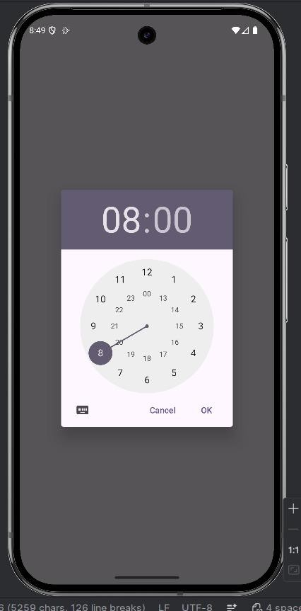

Program-5
Create an activity that uses a menu with three options for dialogue, a number, opening a website and to send an SMS.

activity_main.xml:
<?xml version="1.0" encoding="utf-8"?>
<manifest xmlns:android="http://schemas.android.com/apk/res/android" xmlns:tools="http://schemas.android.com/tools">
<!-- Permissions are not strictly required for ACTION_DIAL, ACTION_VIEW (browser), and ACTION_SENDTO (sms), as they delegate the action to system apps. -->
<application android:allowBackup="true"
android:dataExtractionRules="@xml/data_extraction_rules" android:fullBackupContent="@xml/backup_rules" android:icon="@mipmap/ic_launcher" android:label="@string/app_name" android:roundIcon="@mipmap/ic_launcher_round" android:supportsRtl="true" android:theme="@style/Theme._6ConnectHub">
<activity android:name=".MainActivity" android:exported="true">
<intent-filter>
<action android:name="android.intent.action.MAIN" />

<category android:name="android.intent.category.LAUNCHER" />
</intent-filter>
</activity>
</application>
</manifest>

MainActivity.java:
package com.example.a6connecthub;

import android.content.Intent; import android.net.Uri;
import android.os.Bundle; import android.view.Menu; import android.view.MenuItem; import android.widget.Toast;

import androidx.activity.EdgeToEdge; import androidx.annotation.NonNull;
import androidx.appcompat.app.AppCompatActivity; import androidx.appcompat.widget.Toolbar;
import androidx.core.graphics.Insets; import androidx.core.view.ViewCompat;
import androidx.core.view.WindowInsetsCompat; public class MainActivity extends AppCompatActivity {
@Override
protected void onCreate(Bundle savedInstanceState) { super.onCreate(savedInstanceState);
// Enable edge-to-edge display EdgeToEdge.enable(this); setContentView(R.layout.activity_main);
// Initialize Toolbar
Toolbar toolbar = findViewById(R.id.toolbar); setSupportActionBar(toolbar);

// Handle window insets for edge-to-edge ViewCompat.setOnApplyWindowInsetsListener(findViewById(R.id.main), (v, insets) -> {
Insets systemBars = insets.getInsets(WindowInsetsCompat.Type.systemBars()); v.setPadding(systemBars.left, systemBars.top, systemBars.right, systemBars.bottom); return insets;
});
}

// Inflate the menu resource (menu_main.xml) into the toolbar @Override
public boolean onCreateOptionsMenu(Menu menu) { getMenuInflater().inflate(R.menu.menu_main, menu); return true;
}

// Handle menu item clicks with Intents and Toasts @Override
public boolean onOptionsItemSelected(@NonNull MenuItem item) { int id = item.getItemId();
if (id == R.id.action_dial) {
// Requirement 3a: Dial Number (ACTION_DIAL doesn't require CALL_PHONE permission)

Toast.makeText(this, "Opening Dialer: 9876543210", Toast.LENGTH_SHORT).show(); Intent dialIntent = new Intent(Intent.ACTION_DIAL); dialIntent.setData(Uri.parse("tel:9876543210"));
startActivity(dialIntent); return true;
} else if (id == R.id.action_web) {
// Requirement 3b: Open Website
Toast.makeText(this, "Opening Browser: google.com", Toast.LENGTH_SHORT).show(); Intent webIntent = new Intent(Intent.ACTION_VIEW); webIntent.setData(Uri.parse("https://www.google.com"));
startActivity(webIntent); return true;

} else if (id == R.id.action_sms) {
// Requirement 3c: Send SMS
Toast.makeText(this, "Opening SMS app...", Toast.LENGTH_SHORT).show(); Intent smsIntent = new Intent(Intent.ACTION_SENDTO); smsIntent.setData(Uri.parse("smsto:9876543210")); smsIntent.putExtra("sms_body", "Hello from my app!"); startActivity(smsIntent);
return true;
}

return super.onOptionsItemSelected(item);
}
}

Output-
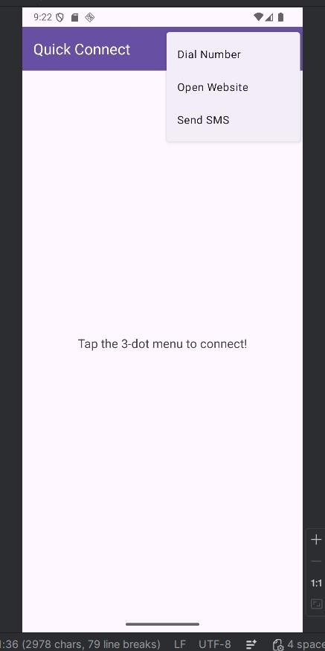

Program-6

Basic music player app.

activity_main.xml:
<LinearLayout xmlns:android="http://schemas.android.com/apk/res/android" android:orientation="vertical"
android:gravity="center" android:layout_width="match_parent" android:layout_height="match_parent">
<Button android:id="@+id/playBtn" android:text="Play"
android:layout_width="wrap_content" android:layout_height="wrap_content"/>
<Button android:id="@+id/pauseBtn" android:text="Pause"
android:layout_width="wrap_content" android:layout_height="wrap_content"/>

<Button android:id="@+id/stopBtn" android:text="Stop"
android:layout_width="wrap_content" android:layout_height="wrap_content"/>
</LinearLayout>

MainActivity.java:
package com.example.musicapp;

import android.media.MediaPlayer; import android.os.Bundle;
import android.view.View; import android.widget.Button;
import androidx.appcompat.app.AppCompatActivity; public class MainActivity extends AppCompatActivity {
Button play, pause, stop;

MediaPlayer mediaPlayer;
@Override
protected void onCreate(Bundle savedInstanceState) { super.onCreate(savedInstanceState); setContentView(R.layout.activity_main);
play = findViewById(R.id.playBtn); pause = findViewById(R.id.pauseBtn); stop = findViewById(R.id.stopBtn);
mediaPlayer = MediaPlayer.create(this, R.raw.song); play.setOnClickListener(v -> mediaPlayer.start()); pause.setOnClickListener(v -> mediaPlayer.pause()); stop.setOnClickListener(v -> {
mediaPlayer.stop();
mediaPlayer = MediaPlayer.create(this, R.raw.song);
});
}
}
Output-

